

发音

**Hello Everyone!**

Welcome to our first assignment sheet. 各位同学，以下就是你们的第一份课后作业

This week, there will be 2 assignment sheets. The recording and/or questions must be sent through CCtalk, using your profile **from the course**. I will respond to your class profile only regarding course content! 这周，会有2份课后作业。个人录音以及各种课程相关问题，还请大家在CCtalk上用已经购买课程的帐号联系我，这样我就可以回答与课程相关的问题！

Assignments are optional. Although I suggest taking them all seriously, you may skip any or all of them. If you decide to submit the recording, please ***practice*** first. I will be harsh in my critique, to help you the most! I don’t expect perfection, but I expect your best effort. Go through the exercises before recording your submission. 这是一份非强制性的作业。 各位同学不必完成全部作业，但是我仍然建议各位同学认真对待。提交个人录音之前，我建议各位同学先好好练习一段时间，因为我对发音这一块的点评是十分严格的，这么做的目的是希望同学们都能快速成长！我不期望同学们达到完美的水平，但是我希望每一位同学都是通过努力练习之后，再录音发送给我。

REMINDER: This is a ‘ground-up’ course. Although some exercises may feel easy, please take them seriously. Focus on **perfection**, not completion. This is the course design.

提示： 目前这还是一堂打基础的课程，尽管有些联系可能比较容易，但是也请同学们认真对待。尽力做到 完美而不是仅仅的完成任务。以上就是这堂课的设计初衷。

Best wishes 祝好，

Riley 老师

**Exercises 练习**

#1

Listen to Audio file “1.mp3” from class resource list and **repeat**. Focus on perfection.

认真并且反复听音频 “1.mp3”，这个文件可在课程文件列表中下载。同学们请尽自己所能做好以下的题目。

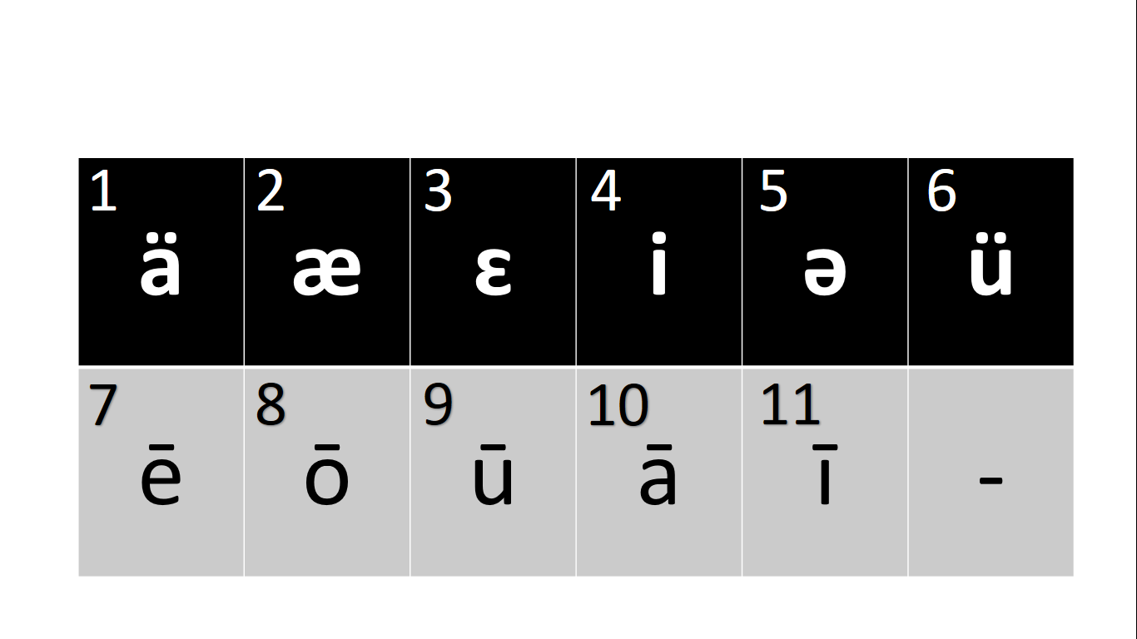

Test your understanding 理解题:

Example 示例:

“Pain” contains which vowel sound? Options 1-11. ___10____

“Pain”这个单词包含以下1-11里哪个元音？

“Walk” contains which vowel sound? Options 1-11. _________

“lose” contains which vowel sound? Options 1-11. _________

“Phil” contains which vowel sound? Options 1-11. _________

“could” contains which vowel sound? Options 1-11. _________

“sigh” contains which vowel sound? Options 1-11. _________

**Exercises 练习**

#2

Listen to Audio file “2.mp3” from class resource list and **repeat**. Focus on perfection.

认真并且反复听音频 “2.mp3”，这个文件可在课程文件列表中下载。同学们请尽自己所能做好以下的题目。(2b.mp3 for columns!)



Test your understanding: 理解题

Example: 示例

“Party” contains which vowel **sounds**? Options 1-11. ___1____ + ___7 ____

“party”这个单词包含1-11里哪些元音?

“staring” contains which vowel **sounds**? Options 1-11. __ ___ + ___ ____

“music” contains which vowel **sounds**? Options 1-11. __ ___ + ___ ____

“plastic” contains which vowel **sounds**? Options 1-11. __ ___ + ___ ____

“seascape” contains which vowel **sounds**? Options 1-11. __ ___ + ___ ____

**Feedback 反馈**

Once you feel you have practiced the exercises, and you are ready for my critique, record the following sentence. Read the sentence **3 times** in the recording. Don’t read too fast; if your recording is less than **35 seconds**, you probably read too fast! am focusing on vowel and consonant sound only. Other aspects will be examined in other recordings, so do not worry. Just make the best sounds you can.

一旦觉得你练习好了，那就说明你已经准备好听我的意见了。请朗读3遍下面的句子并且录音。也请同学们不要都太快，如果你的音频短于35秒，那就说明你可能读的太快了！在这一部分我仅仅关注元音和辅音，其他方面的练习会在后续课程里有涉及，还请同学们不必担心。目前只要好好努力练习这部分发音就好。

“Hey, how could I watch the sunset when the moon is stealing the show?” ***(x3)***

10 2 6 11 1 5 5 3 4 5 9 4 7 4 5 8

(MY recording for practice is titled “HEY.mp3”)

NOTE: You **MUST** send your recording through CCtalk, through the profile assigned to the course. I will respond to your submission within as soon as I can, a few days at most.

注意事项：各位同学务必在cctalk发送你的录音给到我，并确保使用的是购买付费课程的账号。我会尽快回复同学们的消息，诸君加油！